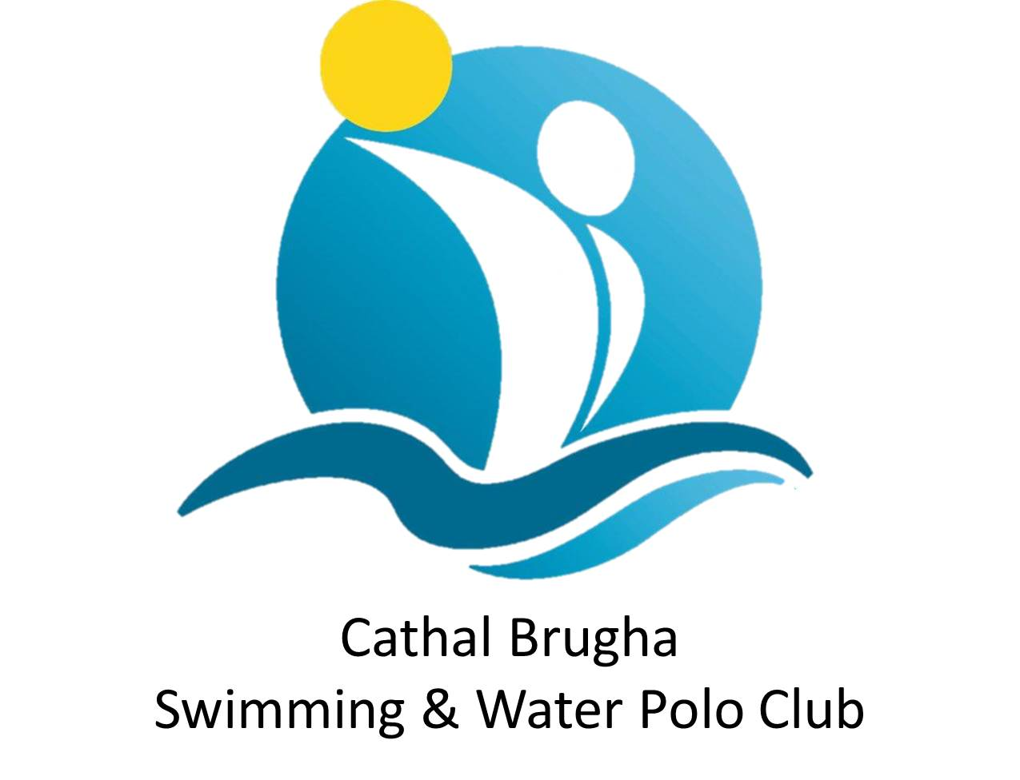

**Chairman’s Corner**

Things are beginning to stir again on the water polo front as we welcome the countdown to the start of the new season.

The season that has just finished had its fair share of ups and downs, but in a superb turnaround we managed to make it to three Irish Cup finals. Our men's team lost by a goal in the final of the Irish Senior Cup and our boys U13 side lost 5-3 in the final of their event with the highlight of the season being provided by our U15 girls side who travelled to Galway and beat Diamonds 11-6 in their Cup final.

Five of that team went on to play for Ireland in the ASA Regional Championships in Millfield school in Somerset where they won the silver medals in the eight-team tournament. Eva Ramsey picked up the MVP Award and scored thirty goals in the process. The other internationals were Maria McGuigan (capt.), Siun McGurk, Cara O'Kane and Ciara McKee. Tegan McGurk, Lucy O'Neill, Phoebe Marron, Niamh O'Connor and Polly Short were the other starts on the cup winning side.

Johnny Donnelly (capt.), Chris Devlin, Stio McMahon and the Hanna brothers Adrian and Matthew all played on the Ireland men's team.

Hannah Taylor was goalie for the Ireland women’s team but on the debit side Lynn Hanna Short and Deirdre Cassidy drew the curtain on outstanding international careers with the women's team.

Our Fundamentals programme with Peter and Deirdre Cassidy, Lynn Hanna Short, Damian O'Neill and Paul Goss in attendance has been a huge success and resumes 7th September. Details of our teaching and training programme for the year are on the website.

***CATHAL BRUGHA BULLETIN***

*It was a busy end to the season with several Cathal Brugha members representing Ireland overseas. We hope you had an enjoyable summer and are ready for another action-packed year of training, competitions and fun. Training sessions have commenced again, check the website for details.*

### **Dates for your diary**

***To keep updated with club news & craic, join the Cathal Brugha News Whatsapp group by messaging 07912 862220***

**Sunday 23 September** – Abseil at Europa Hotel, times tbc depending on match schedule. Sponsorship forms available on the website.

**Friday 28 September** – Club dinner at Beechlawn Hotel, 8pm, tickets £30 and will be available soon.

***A calendar of events and fundraising activities will be available shortly – any club fundraising must be approved by the committee in advance – email your ideas for other fundraising activities this season by 6 September to info@cathalbrughawaterpolo.com***

**League & Cup Entries**

This year Cathal Brugha teams will compete in the following leagues & cups:

**Men**: Irish Senior Cup & Bro Philip Cup, National League Div 1 & Nat League Div 2

**Ladies**: Irish Senior Cup & KO Cup, and Nat League Div 1

**Girls:** U16 National League

U19, U17 and U15 cups: Boys & Girls teams. U13 mixed cup team

**The league schedule will be issued shortly by Ireland Water Polo.**

|  |  |  |
| --- | --- | --- |
| **ASDA SUPPORT**  We are delighted to have received £200 from Asda Westwood for their green tokens scheme. We hope to have a bag pack at Asda before Christmas, it would be great to have members young and old helping out, a date will be confirmed asap.  **SKILLS CAMPS**  Ulster Water Polo have been running a series of very successful skills camps this year for junior players. The next camps are on 31 August (for U15 and U17 girls) and 7 September (U15 and U17 boys).  Ulster teams will be selected in early September for an U15 and U17 InterPro tournament taking place in Bangor on 2/3 November. Teams from Leinster, Connacht and Scotland will also take part.  **CLUB GEAR FOR CHRISTMAS?**  The new club gear has been a big hit with members. You can order yours directly from the club website, it would make a perfect Christmas present! **AQUATICS STRATEGY** Belfast City Council is consulting on a new aquatics strategy – to have your say, complete the survey at <https://yoursay.belfastcity.gov.uk/parks-and-leisure/aquatics-strategy/> before 12 October. |  | **YOUR CLUB NEEDS YOU!**  We need your help to update our records and to ensure our compliance with a Swim Ireland directive! All Clubs have recently been contacted by Swim Ireland/Ireland Water Polo, who are updating Membership records as part of their GDPR/Data Protection compliance work.  Cathal Brugha has received instructions, which we MUST comply with, to meet these new information management standards. In short, Clubs need to contact their Members and seek permission from those Members holding qualifications to link their qualifications to their Club.  Please follow this link to our website ([http://cathalbrughawaterpolo.com/…/coaching-and-other-quali…](https://l.facebook.com/l.php?u=http%3A%2F%2Fcathalbrughawaterpolo.com%2Fblog%2Fview%2Fcoaching-and-other-qualifications&h=AT1pQh9BV_TREaWUaFMFw3-e3VP94e0_kMnXdpUzh7dTwMLG0jXuXdhukt-kZJ0J3j8hgiC1ApcULmM07Ry-2_CgXuBaYnn_0pBR_uDKS0o42G1sGNknZ9fLPN1NWT26NMavjBkb6ozV7glm5DNGkgs)) for further information on how you can help us comply with Swim Ireland regulations.  Your **urgent attention** to this matter is very much needed to ensure we remain in step with Swim Ireland regulations…**we need your response before end August!**  **SUMMER MADNESS**  Some of our junior members took part in a fun day at Bryson Lagansports in June to round off a special season. Along with dragon boating, kayaking and water walking, everyone got an award for their contribution to the club. We hope to make this an even bigger event next year. Special thanks to Ciaran & Stephen for a delicious BBQ!  **SAFEGUARDING COURSES THIS AUTUMN**  Swim Ulster have arranged 3 Safeguarding courses to ensure club volunteers have the required certificates for their roles for the incoming season. All courses are from 6.30 – 9.30pm and dates are: 12th September 2018, Clayton Hotel; 10th October, Lagan Valley LC; and 24th October, Clayton Hotel. If interested in the course, please email [info@cathalbrughawaterpolo.com](mailto:info@cathalbrughawaterpolo.com). |